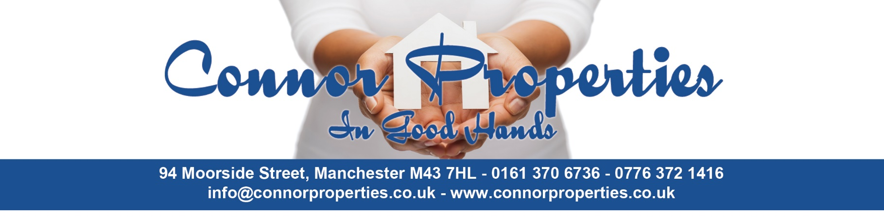

Connor Properties Tenant Information Pack
Welcome to your new home with Connor Properties.
This Tenant Information Pack outlines important policies, responsibilities, and guidance to help you understand your rights and obligations as a tenant. It includes essential information on repairs, anti-social behaviour, condensation prevention, and how we handle your personal data.
Please take time to read through this pack carefully. If you have any questions, don’t hesitate to contact us.

Contents
- 1. Repairs Policy
- 2. Anti-Social Behaviour Policy
- 2.1 How we handle reports
- 3. Condensation Advice
- 4. Privacy Notice
- 5. Acknowledgement & Signature

ALL YOU NEED TO KNOW ABOUT REPAIRS
You’ll probably already know that there are some repairs we can do for you free of charge, and some which are your responsibility to sort out – these are called chargeable repairs, but how does it work?
When you contact us to carry out a repair, we will tell you if this is a ‘chargeable repair’ and the cost of carrying it out. Generally, if a repair is rechargeable, we will ask you to pay in full BEFORE we carry it out but, in some cases, may agree to a phased repayment contract, with a deposit upfront and repayment over several weeks.
A rechargeable repair applies to any deliberate damage, misuse or neglect of your property, fixtures and fittings or any communal areas caused by you, your family or your friends/visitors.
This isn’t an exhaustive list but here are a few examples to give you an idea of the type of repairs we would expect you to pay for, based on the above circumstances:
- Unblocking a sink or toilet
- Re-glazing a window
- Changing alterations, you have made without first obtaining our approval
- Changing a lock because you have lost your keys
- Replacing your keys because you have lost them

- Repairing/replacing internal or external doors or other fixtures/fittings
- Clearing out your personal items when you leave the property
- Replacing your toilet seat
- Replacing and fitting light bulbs

ANTISOCIAL BEHAVIOUR POLICY
Whilst we do not anticipate any issues during your tenancy, we must make it clear that anti-social behaviour will not be tolerated under any circumstances.
We recognise that there can sometimes be a fine line between minor disputes between neighbours and behaviour that becomes persistently disruptive. However, ongoing or serious incidents may be considered anti-social behaviour. Examples of anti-social behaviour include, but are not limited to:
- Intimidation of neighbours or others through threats or violence
- Harassment, including racial or discriminatory harassment
- Verbal abuse
- Homophobic or discriminatory behaviour
- Abusive conduct intended to cause distress or fear, especially toward vulnerable individuals (e.g., elderly or disabled persons)
- Excessive or persistent noise
- Dumping rubbish in communal or public areas
- Animal nuisance, including dog fouling
- Vandalism, graffiti, or deliberate damage to property

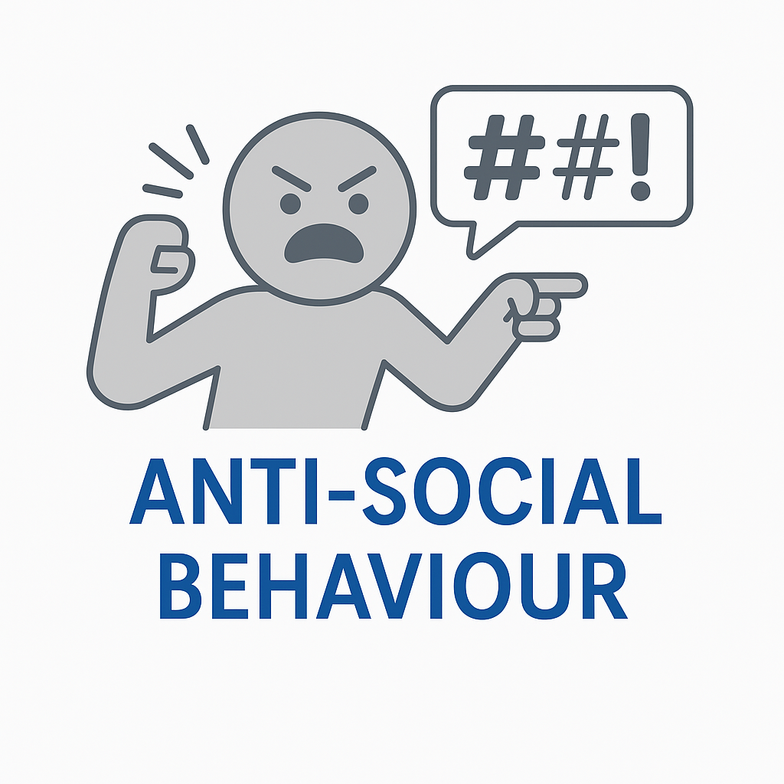

HOW WE HANDLE REPORTS OF ANTI-SOCIAL BEHAVIOUR
Our approach to addressing serious or persistent anti-social behaviour is as follows:
- Initial Complaint & Evidence Gathering
Upon receiving a complaint, we will speak with the individuals involved and gather evidence. This may include names, addresses, incident dates, and times. Where appropriate, we may also seek statements from other neighbours or third-party agencies.
- Tenant Engagement
Once sufficient information has been gathered; we will contact the tenant in question to discuss the matter and provide an opportunity to respond.
- Formal Warning
If the issue is not resolved informally, a written warning will be issued to the tenant, requiring the behaviour to cease immediately. This letter will make clear that the landlord reserves the legal right to seek possession of the property if it can be proven in court that the tenant's actions have caused serious and ongoing nuisance or disruption.

We are committed to acting fairly, reasonably, and without prejudice always. However, we take anti-social behaviour extremely seriously.
Persistent or severe anti-social behaviour may lead to the termination of your tenancy and legal proceedings for possession of the property. Please be aware that tenants found guilty of such behaviour may also face challenges securing alternative accommodation, as they could be deemed to have made themselves intentionally homeless.

Condensation & Damp Prevention Guide
Condensation and damp are common problems in rented properties, especially during the colder months. Taking a few simple steps can help you prevent these issues and maintain a healthy living environment.
Tips to Reduce Condensation & Prevent Damp
- Open windows daily for at least 10-15 minutes to allow fresh air to circulate.
- Use extractor fans, if possible, in kitchens and bathrooms while cooking or showering.
- Keep lids on pans while cooking and avoid excessive boiling.
- Dry clothes outdoors when possible or use a vented tumble dryer.
- If drying clothes indoors, use a drying rack in a well-ventilated room.
- Keep furniture slightly away from walls to allow air to flow around.
- Maintain a consistent temperature throughout your home to avoid cold surfaces.
- Wipe down windows and sills in the morning if condensation has formed.
- Keep internal doors closed when cooking or showering to contain moisture.
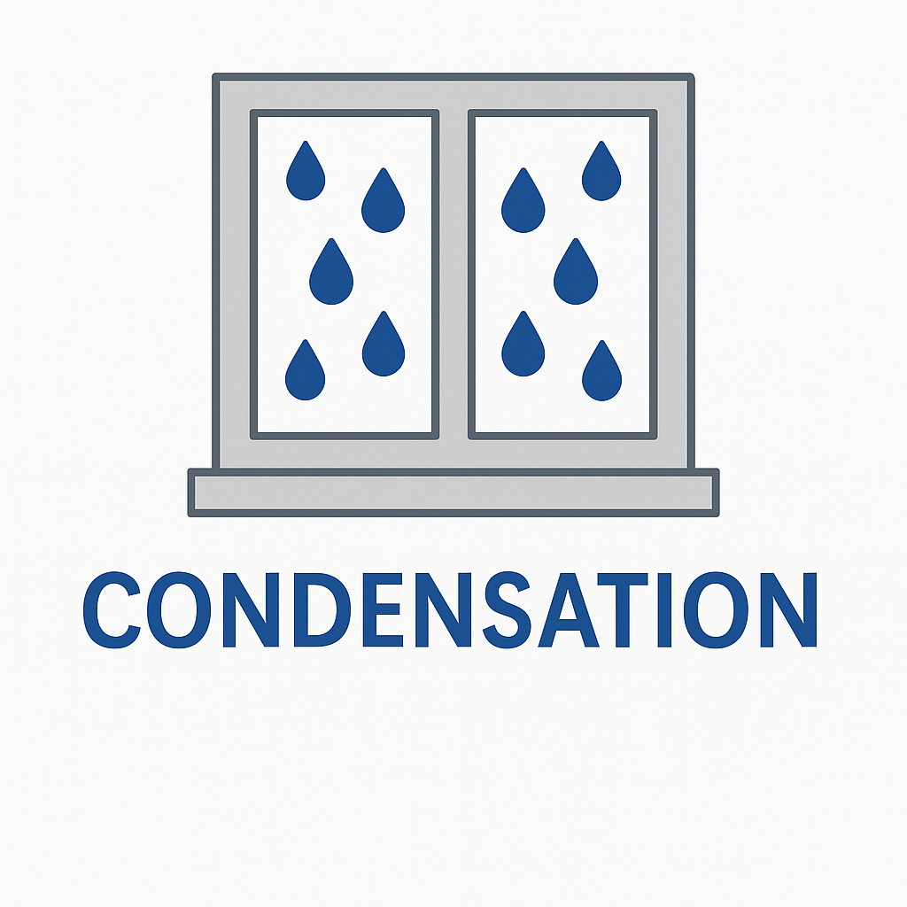
- Report any signs of persistent damp or mould to you landlord

Blocked Drains – Prevention Advice for Tenants
Blocked drains can cause bad smells, slow drainage, and costly repairs. Many blockages are easily preventable by taking a few simple precautions in your day-to-day habits.
Preventing Blocked Sinks and Drains
DO NOT:
• Pour cooking oil, grease, or fat down the sink
• Wash food scraps down the sink
• Pour coffee grounds, tea leaves, or sauces down the drain
DO:
• Wipe greasy pans with a paper towel and put it in the bin before washing
• Use a sink strainer or plug sieve to catch food waste
• Pour cooled fat or oil into a disposable container and bin it once solid
Toilets – What NOT to Flush
Only the 3 Ps – Pee, Poo, and (toilet) Paper – should go down the toilet.
DO NOT FLUSH:
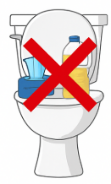
• Wet wipes (even if marked 'flushable')
• Cotton pads or buds
• Sanitary towels or tampons
• Nappies or liners
• Hair
• Grease or oil
Shower and Bath Drains
• Use a drain catcher to trap hair and soap scum
• Regularly clear hair from the plughole

If You Notice a Problem
Common signs of a blocked drain include:
- Water draining slowly from sinks, baths, or showers
- Gurgling sounds from plugholes
- Bad smells coming from drains
- Toilet not flushing properly
If you notice any of these issues, report them to us immediately to avoid further damage. Please note that tenants may be charged for unblocking drains caused by misuse.
Let's work together to keep your drains clean and your home running smoothly.
If in doubt – bin it, don’t flush it!

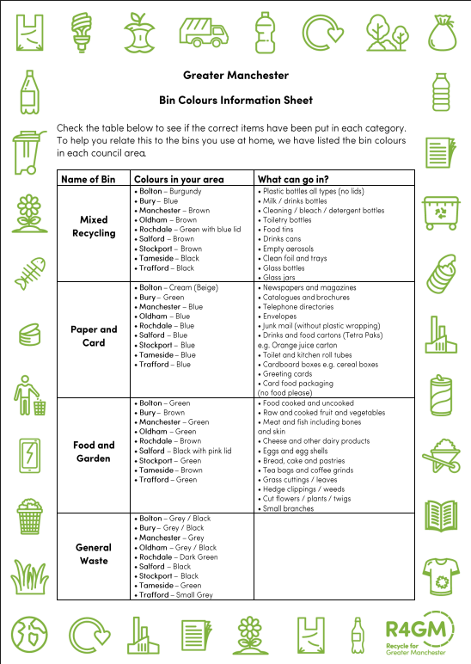
Recycling

Acknowledgement & Signature
I confirm that I have read and understood the policies outlined in this Tenant Information Pack provided by
Connor Properties Ltd. I agree to abide by the responsibilities and expectations set out in this document.

Signed:

Print Name:

Date:

